IP Lab Syllabus
WEBPAGE CONCEPTS
Exp1 : Create a web page with the following using HTML
a. To embed a map in a web page
b. To fix the hot spots in that map
c. Show all the related information when the hot spots are clicked
.
Exp2 : Create a web page with the following.
a. Cascading style sheets.
b. Embedded style sheets.
c. Inline style sheets. Use our college information for the web pages.
Exp3: Create and save an XML document at the server, which contains 10 users Information. Write a Program, which takes user Id as an input and returns the User details by taking the user information from the XML document.

SERVLETS and JSP
Exp 4: Write programs in Java using Servlets:To invoke servlets from HTML forms
Exp 5: Write a program in java To invoke servlets from Applets
Exp 6:
a)Install TOMCAT web server. Convert the static webpages using dynamic web pages using servlets (or JSP) and cookies
i) Write programs in Java to create three-tier applications using servlets for conducting on-line examination for displaying student mark list.
ii) Session tracking using hidden form fields and Session tracking for a hit count
Exp 7: Write a program to lock servlet itself to a particular server IP address and port number. It requires an init parameter key that is appropriate for its servlet IP address and port before it unlocks itself and handles a request
SOCKET
Exp 8 Write a program in Java for creating simple chat application with datagram sockets and datagram packets.

Exp9 Write programs in Java using sockets to implement the following:
i. HTTP request
ii. FTP
iii. SMTP
iv. POP3

Exp1. CREATE A WEB PAGE using Image Map

Aim:

CREATE A WEB PAGE WITH THE FOLLOWING USING HTML
i) To embed an image map in a web page
ii) To fix the hot spots
iii) Show all the related information when the hot spots are clicked.

Steps:
- Create Html Document with Head and body section
- Insert map image into html document
<img src=”filename.jpg“ height =” ” width=” ”>
- Create map and mark coordination Point
<map name=” “ id=””>
create links for the All coordination point
<area href='filename.html' coords='175,495,30' >
- .Add use map attribute to the image tag
<img src="" usemap="#mapid" >
- Crate Linked Html document and View the output browser

ImageMap.html
<HTML>
<HEAD>
<TITLE>Image Map</TITLE>
</HEAD>
<BODY><img src="india_map.jpg" usemap="#metroid" >
<map name="metroid" id="metroid">
<area href='TamilNadu.html' shape='circle' coords='175,495,30'title='TamilNadu'/>
<area href = "Karnataka.html" shape = "rect" coords = "100,400,150,450" title ="Karnataka" />
<area href = "AndhraPradesh.html" shape = "poly" coords = "150,
415,175,348,265,360,190,420,190,440" title =
"Andhra Pradesh" />
<area href = "Kerala.html" shape = "poly" coords =
"108,455,150,515,115,490,148,495,110,448,155,501" title =
"Kerala" />
</map>
</BODY>
</HTML>
TamilNadu.html
<HTML>
<HEAD>
<TITLE>About Tamil Nadu</TITLE>
</HEAD>
BODY>
<CENTER><H1>Tamil Nadu</H1></CENTER>
<HR>
<UL>
<LI>Area : 1,30,058 Sq. Kms.</LI>
<LI>Capital : Chennai</LI>
<LI>Language : Tamil</LI>
<LI>Population : 6,21,10,839</LI>
</UL><hr>
<a href='ImageMap.html'>India Map</a>
</BODY>
</HTML>
Karnataka.html
<HTML>
<HEAD>
<TITLE>About Karnataka</TITLE>
</HEAD>
<BODY>
<CENTER><H1>Karnataka</H1></CENTER>
<HR>
<UL>
<LI>Area : 1,91,791 Sq. Kms</LI>
<LI>Capital : Bangalore</LI>
<LI>Language : Kannada</LI>
<LI>Population : 5,27,33,958</LI>
</UL>
<hr>
<a href='ImageMap.html'>India Map</a>
</BODY>
</HTML>
AndhraPradesh.html
<HTML>
<HEAD>
<TITLE>About Andhra Pradesh</TITLE>
</HEAD>
<BODY>
<CENTER><H1>Andhra Pradesh</H1></CENTER>
<HR>
<UL>
<LI>Area : 2,75,068 Sq. Kms</LI>
<LI>Capital : Hyderabad</LI>
<LI>Language : Telugu</LI>
<LI>Population : 7,57,27,541</LI>
</UL><hr>
<a href='ImageMap.html'>India Map</a>
</BODY>
</HTML>
Kerala.html
<HTML>
<HEAD>
<TITLE>About Kerala</TITLE>
</HEAD>
<BODY>
<CENTER><H1>Kerala</H1></CENTER>
<HR>
<UL>
<LI>Area : 38,863 Sq. Kms.</LI>
<LI>Capital : Thiruvananthapuram</LI>
<LI>Language : Malayalam</LI>
<LI>Population : 3,18,38,619</LI>
</UL><hr>
<a href='ImageMap.html'>India Map</a>
</BODY>
</HTML>
OUTPUT:
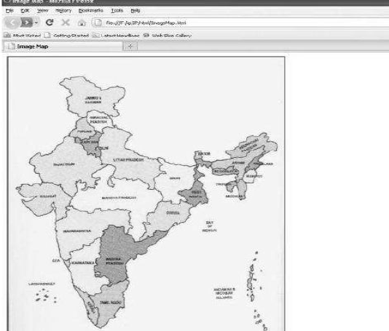

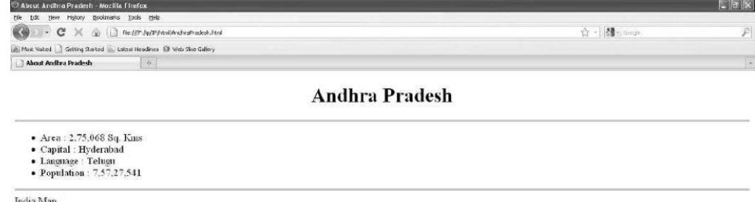

Exp2. CREATE A WEB PAGE WITH ALL TYPES OF CASCADING STYLE SHEETS.

Refer Assignment 4 Write your own include HTML Document with home page at least 4 links and CSS file

Exp3. Create and save an XML document and Write ActiveX Script Read Particular use information

Aim: Create and save an XML document which contains 10 users Information. Write a Program, which takes user Id as an input and returns the User details by taking the user information from the XML document

Steps :

- Create an XML Document which contain 10 student Details Like rno,name dept of each student with root element pec save file as a.xml
- Crate HTML Document which contain button
- Include internal java Script with function that get Rno from user by using prompt
- Create an ActiveX object using Microsoft.XMLDOM
- Using Activex to Object read XML document and store into another object
- Using that object call the ,method getElementsByTagName("tagname") and store into array object
- Read All element in the each student ill the full length of the array by using xmldoc.getElementsByTagName("rno")[i].childNodes[0].nodeValue;
- Match the input Rno and current student rno in the xml document read and print other details of the student

<pec>
<student>
<rno>1</rno>
<name>XXX</name>
<dept>CSE</dept>

</student>
<student>
<rno>2</rno>
<name>yyy</name>
<dept>CSE</dept>

</student>
<student>
<rno>3</rno>
<name>zzz</name>
<dept>CSE</dept>

</student>
</pec>

<html>
<head>

<script>
function validate()
{

xmldoc=new ActiveXObject("Microsoft.XMLDOM");
xmldoc.async="false";
xmldoc.load("a.xml");
var x=prompt("Enter rno to find the data");
arr=xmldoc.getElementsByTagName("student");

for(i=0;i<arr.length;i++)
{

var txt=xmldoc.getElementsByTagName("rno")[i].childNodes[0].nodeValue;
var txt1=xmldoc.getElementsByTagName("name")[i].childNodes[0].nodeValue;
var txt2=xmldoc.getElementsByTagName("dept")[i].childNodes[0].nodeValue;
if(txt==x)
{
document.writeln(txt);
document.writeln(txt1);
document.writeln(txt2);
document.writeln("<br>");
}

}

}
</script>
</head>
<body>
<form name="myform">
<input type="submit" value="submit" name="b1" onClick="validate()">
</form>
</body>
</html>

Output

